City Care Hospital Database Assignment
Name: Shubham Somani
Roll Number: 0081
Subject: Data Warehousing and Management
Course: MBA Healthcare Analytics, IIHMR University
Date: 15/10/2026

Assignment Overview
This assignment develops a small relational database for City Care Hospital. The database contains patient, doctor, appointment and billing information. The SQL queries demonstrate filtering, sorting, aggregation and joins.

Part A: Database and Table Creation
Run the accompanying .sql script in MySQL Workbench. It creates the database city_care_hospital and the four tables: patients, doctors, appointments and bills.
Relationships: patients (1) → (many) appointments
· doctors (1) → (many) appointments
· appointments (1) → (1) bills.
Dataset creation (tables + sample data)
CREATE DATABASE city_care_hospital;
USE city_care_hospital;
SELECT DATABASE();
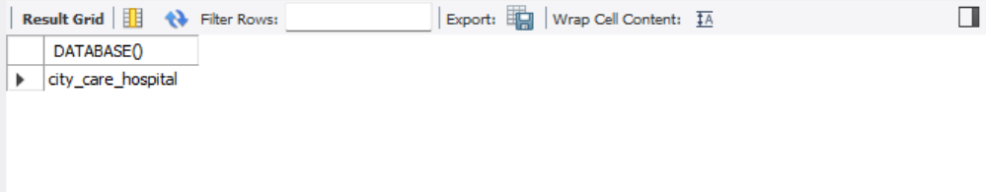

CREATE TABLE patients (
patient_id INT PRIMARY KEY,
first_name VARCHAR(50) NOT NULL,
last_name VARCHAR(50) NOT NULL,
gender CHAR(1),
date_of_birth DATE NOT NULL,
blood_group VARCHAR(3),
city VARCHAR(50),
phone VARCHAR(15),
CHECK (gender IN ('M', 'F', 'O')
));

DESCRIBE patients;

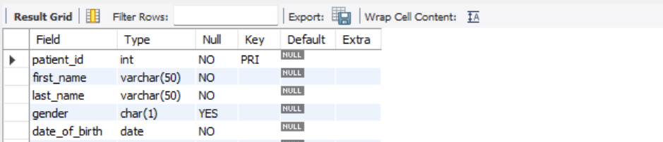

CREATE TABLE doctors (
doctor_id INT PRIMARY KEY,
doctor_name VARCHAR(100) NOT NULL,
specialization VARCHAR(50) NOT NULL,
experience_years INT,
consultation_fee DECIMAL(8,2),
CHECK (consultation_fee > 0)
);

DESCRIBE doctors;
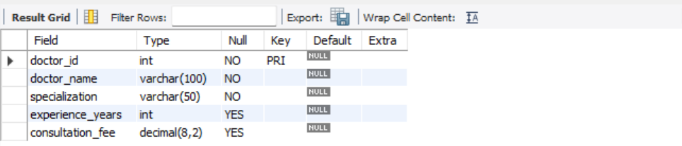

CREATE TABLE appointments (
appointment_id INT PRIMARY KEY,
patient_id INT,
doctor_id INT,
appointment_date DATE NOT NULL,
status VARCHAR(20),
diagnosis VARCHAR(100),

FOREIGN KEY (patient_id)
REFERENCES patients(patient_id),

FOREIGN KEY (doctor_id)
REFERENCES doctors(doctor_id)
);

DESCRIBE appointments;
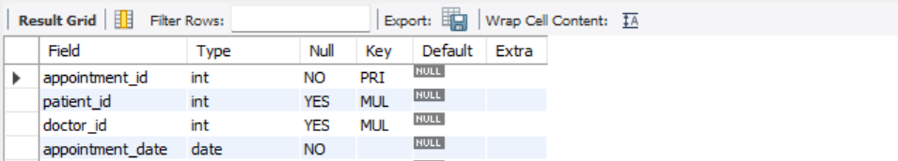

CREATE TABLE bills (
bill_id INT PRIMARY KEY,
appointment_id INT UNIQUE,
total_amount DECIMAL(10,2),
payment_mode VARCHAR(20),
payment_status VARCHAR(10),

FOREIGN KEY (appointment_id)
REFERENCES appointments(appointment_id),

CHECK (total_amount >= 0)
);

DESCRIBE bills;
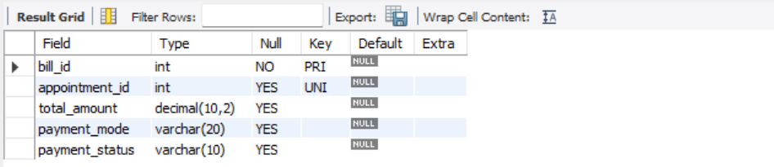

SHOW TABLES;
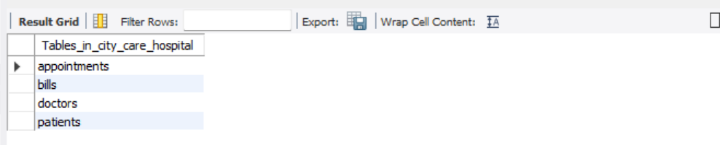

#Data insert into patient table
INSERT INTO patients
(patient_id, first_name, last_name, gender, date_of_birth,
blood_group, city, phone)
VALUES
(1, 'Aarav', 'Sharma', 'M', '1958-04-12', 'B+', 'Jaipur', '9800000001'),
(2, 'Ishita', 'Meena', 'F', '2015-09-30', 'O-', 'Ajmer', '9800000002'),
(3, 'Rahul', 'Verma', 'M', '1995-06-15', 'A+', 'Jaipur', '9800000003'),
(4, 'Priya', 'Gupta', 'F', '1988-03-22', 'AB+', 'Kota', '9800000004'),
(5, 'Aman', 'Singh', 'M', '2000-11-10', 'O+', 'Jaipur', '9800000005'),
(6, 'Sneha', 'Jain', 'F', '1960-07-18', 'A-', 'Jodhpur', '9800000006'),
(7, 'Karan', 'Mehta', 'M', '2018-02-05', 'AB-', 'Jaipur', '9800000007'),
(8, 'Pooja', 'Yadav', 'F', '1992-12-25', 'B-', 'Ajmer', '9800000008'),
(9, 'Rohan', 'Joshi', 'M', '1975-08-09', 'O+', 'Jaipur', '9800000009'),
(10, 'Neha', 'Agarwal', 'F', '1985-05-14', 'B+', 'Kota', '9800000010'),
(11, 'Vikas', 'Choudhary', 'M', '1962-10-20', 'A+', 'Jaipur', '9800000011'),
(12, 'Ananya', 'Soni', 'F', '2005-01-30', 'O-', 'Udaipur', '9800000012');

SELECT * FROM patients;
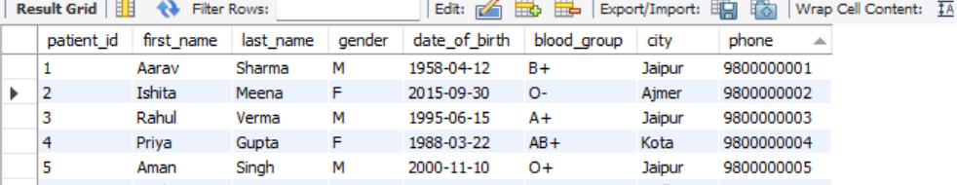
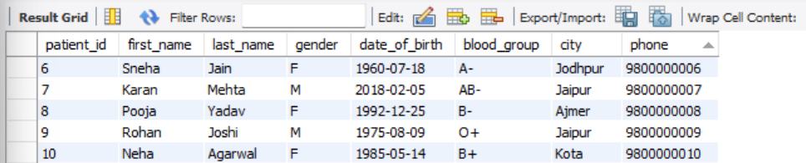

#Data insert into doctors table
INSERT INTO doctors
(doctor_id, doctor_name, specialization, experience_years, consultation_fee)
VALUES
(101, 'Dr. Neha Gupta', 'Cardiology', 15, 1200.00),
(102, 'Dr. Rakesh Singh', 'Paediatrics', 6, 500.00),
(103, 'Dr. Amit Sharma', 'Orthopaedics', 12, 1000.00),
(104, 'Dr. Priya Jain', 'General Medicine', 5, 400.00),
(105, 'Dr. Suresh Mehta', 'Dermatology', 20, 1500.00),
(106, 'Dr. Kavita Rao', 'Cardiology', 2, 800.00);

SELECT * FROM doctors;



#Data insert into appointments table
INSERT INTO appointments
(appointment_id, patient_id, doctor_id, appointment_date, status, diagnosis)
VALUES
(1001, 1, 101, '2025-08-14', 'Completed', 'Hypertension'),
(1002, 2, 102, '2026-01-20', 'Scheduled', NULL),
(1003, 3, 103, '2025-09-10', 'Completed', 'Fracture'),
(1004, 4, 104, '2025-10-05', 'Cancelled', NULL),
(1005, 5, 101, '2026-02-12', 'Completed', 'Viral Fever'),
(1006, 6, 105, '2025-11-18', 'Completed', 'Skin Allergy'),
(1007, 7, 102, '2026-03-15', 'No-show', NULL),
(1008, 8, 103, '2026-04-10', 'Completed', 'Knee Pain'),
(1009, 1, 104, '2026-05-12', 'Completed', 'Diabetes'),
(1010, 3, 105, '2025-12-01', 'Scheduled', NULL),
(1011, 5, 103, '2026-06-08', 'Completed', 'Back Pain'),
(1012, 9, 101, '2025-07-22', 'Completed', 'Hypertension'),
(1013, 10, 102, '2026-07-11', 'Cancelled', NULL),
(1014, 11, 104, '2025-08-30', 'Completed', 'Fever'),
(1015, 12, 105, '2026-08-19', 'Completed', 'Dermatitis'),
(1016, 2, 101, '2025-09-25', 'Completed', 'Anaemia'),
(1017, 4, 103, '2026-09-05', 'No-show', NULL),
(1018, 6, 102, '2025-10-15', 'Completed', 'Migraine'),
(1019, 8, 104, '2026-09-20', 'Scheduled', NULL),
(1020, 9, 105, '2025-11-25', 'Completed', 'Skin Infection');

SELECT * FROM appointments;
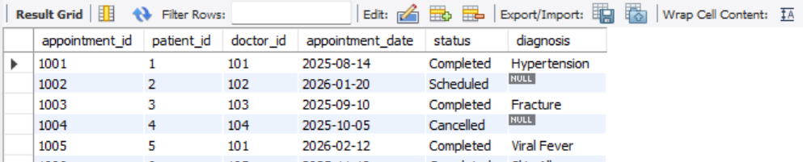
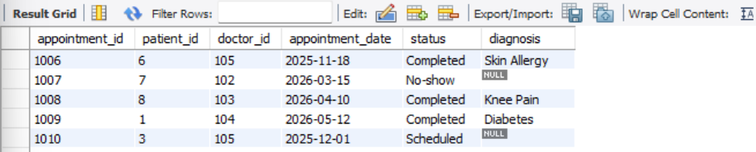
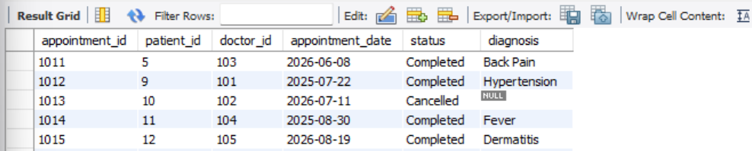
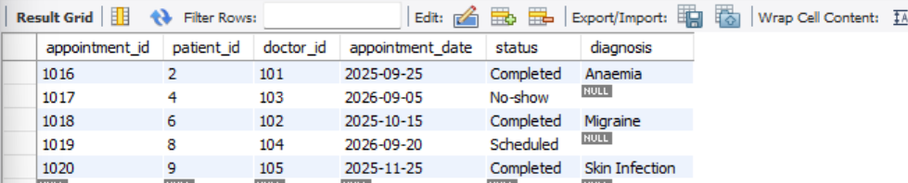

# Data insert into billing table
INSERT INTO bills
(bill_id, appointment_id, total_amount, payment_mode, payment_status)
VALUES
(5001, 1001, 2450.00, 'Insurance', 'Pending'),
(5002, 1003, 3500.00, 'UPI', 'Paid'),
(5003, 1005, 1800.00, 'Cash', 'Paid'),
(5004, 1006, 2200.00, 'Card', 'Pending'),
(5005, 1008, 2800.00, 'UPI', 'Paid'),
(5006, 1009, 1900.00, 'Insurance', 'Pending'),
(5007, 1011, 3200.00, 'Card', 'Paid'),
(5008, 1012, 2600.00, 'Cash', 'Paid'),
(5009, 1014, 1500.00, 'UPI', 'Pending'),
(5010, 1015, 2400.00, 'Insurance', 'Paid'),
(5011, 1016, 1700.00, 'Card', 'Paid'),
(5012, 1018, 2100.00, 'Cash', 'Pending');

SELECT * FROM bills;
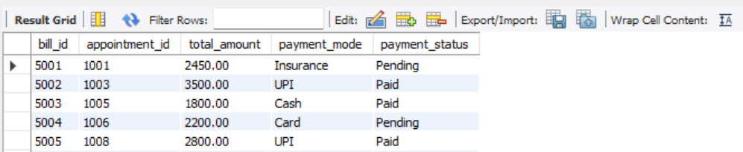
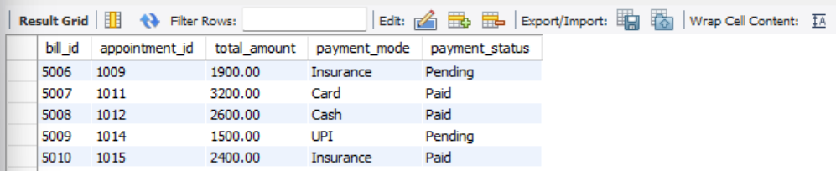

#Part B — SQL 13 Queries
#B1--SELECT and WHERE
# Q1. Display first name, last name, gender and blood group of all patients.
SELECT first_name, last_name, gender, blood_group
FROM patients;
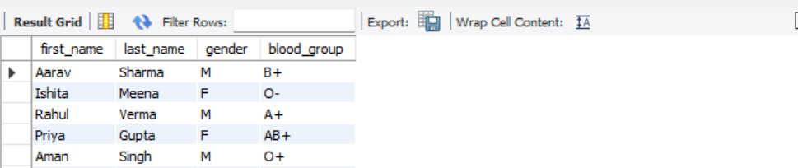
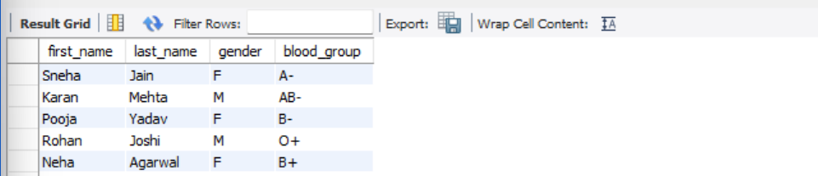

# Q2. List all patients who live in Jaipur.
SELECT *
FROM patients
WHERE city = 'Jaipur';
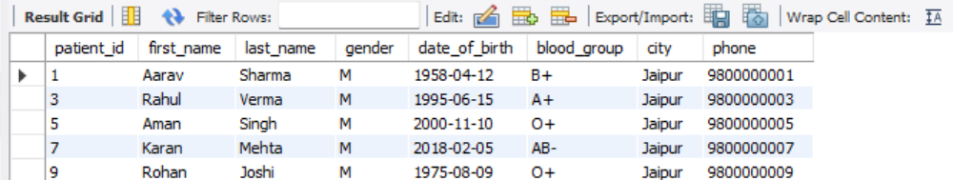

# Q3. Doctors whose consultation fee is above ₹800 and who have at least 10 years of experience.
SELECT *
FROM doctors
WHERE consultation_fee > 800
AND experience_years >= 10;
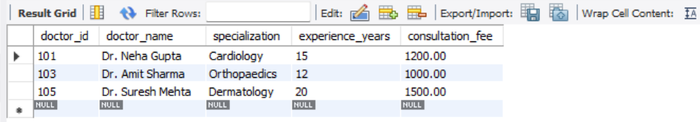
# Q4. List patients with blood group O- or AB- using IN.
SELECT *
FROM patients
WHERE blood_group IN ('O-', 'AB-');
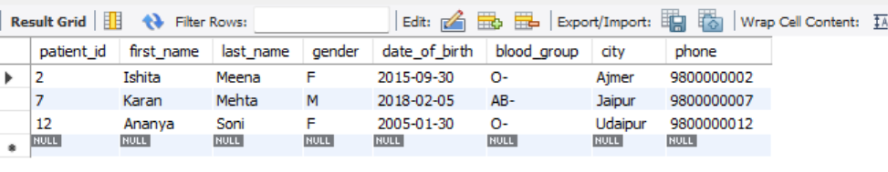

B2—Order By
#Q5. List doctors sorted by consultation fee from highest to lowest.
SELECT *
FROM doctors
ORDER BY consultation_fee DESC;


#Q6. Sort patients by city alphabetically and, within each city, oldest to youngest.
SELECT *
FROM patients
ORDER BY city ASC, date_of_birth ASC;
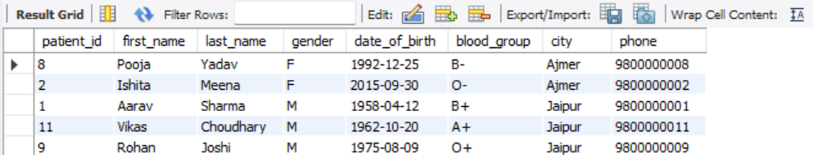
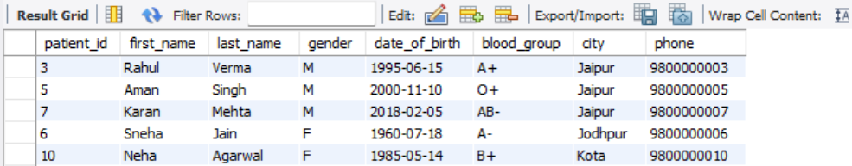

#B3--GROUP BY and HAVING
#Q7. The number of patients in each blood group.
SELECT blood_group, COUNT(*) AS total_patients
FROM patients
GROUP BY blood_group;
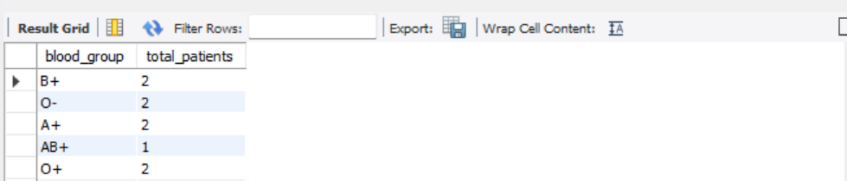

#Q8. The number of appointments for each status.
SELECT status, COUNT(*) AS total_appointments
FROM appointments
GROUP BY status;
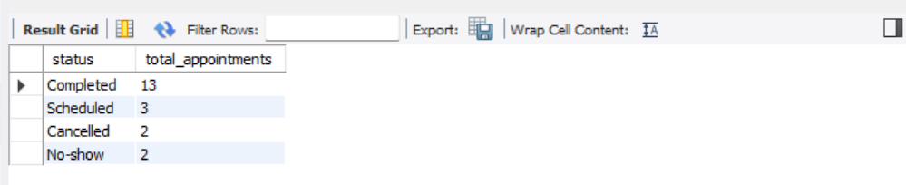

# Q9. List doctor IDs of doctors who have handled more than 2 appointments, with counts.
SELECT doctor_id, COUNT(*) AS total_appointments
FROM appointments
GROUP BY doctor_id
HAVING COUNT(*) > 2;
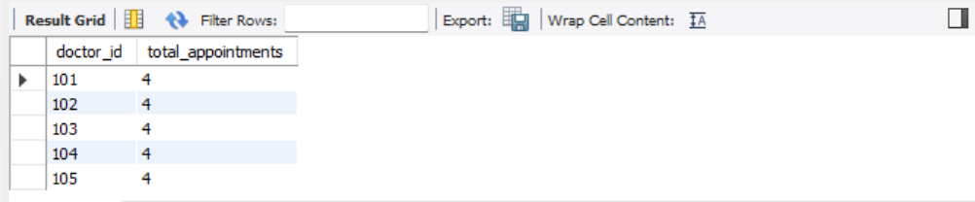

B4—JOIN
#B4--Q10. Using INNER JOIN, appointment date, patient full name, doctor name and specialization.
SELECT
a.appointment_date,
CONCAT(p.first_name, ' ', p.last_name) AS patient_name,
d.doctor_name,
d.specialization
FROM appointments a
INNER JOIN patients p
ON a.patient_id = p.patient_id
INNER JOIN doctors d
ON a.doctor_id = d.doctor_id;
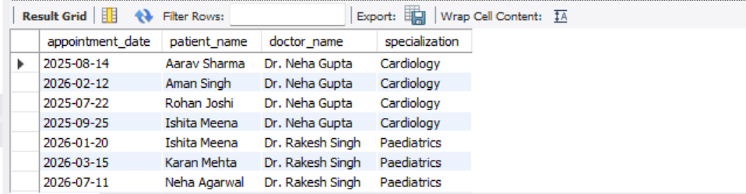
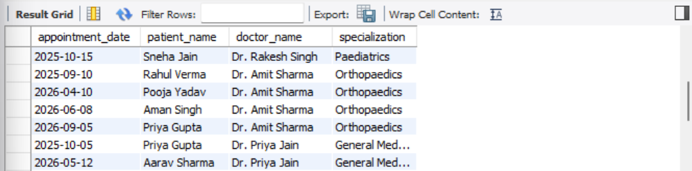


#B4--Q11. Using LEFT JOIN, list all patients with appointment dates, including patients with no appointments.
SELECT
p.patient_id,
CONCAT(p.first_name, ' ', p.last_name) AS patient_name,
a.appointment_date
FROM patients p
LEFT JOIN appointments a
ON p.patient_id = a.patient_id;
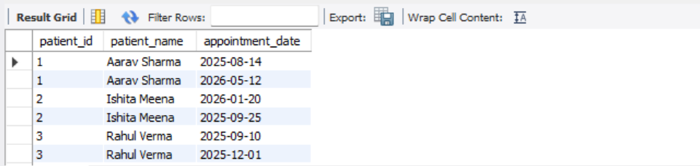
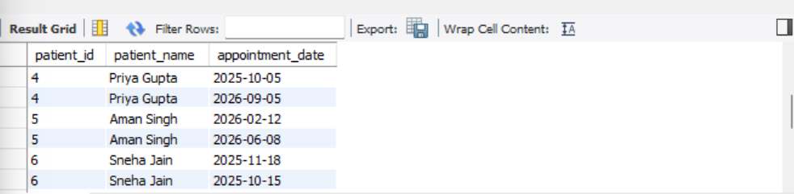
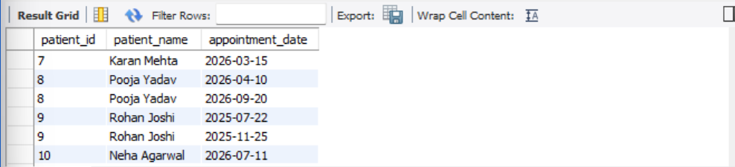

# Identify patients who have never booked an appointment.
SELECT
p.patient_id,
CONCAT(p.first_name, ' ', p.last_name) AS patient_name
FROM patients p
LEFT JOIN appointments a
ON p.patient_id = a.patient_id
WHERE a.appointment_id IS NULL;

#B4--Q12. Patient name, diagnosis and bill amount for pending bills.
SELECT
CONCAT(p.first_name, ' ', p.last_name) AS patient_name,
a.diagnosis,
b.total_amount,
b.payment_status
FROM patients p
INNER JOIN appointments a
ON p.patient_id = a.patient_id
INNER JOIN bills b
ON a.appointment_id = b.appointment_id
WHERE b.payment_status = 'Pending';
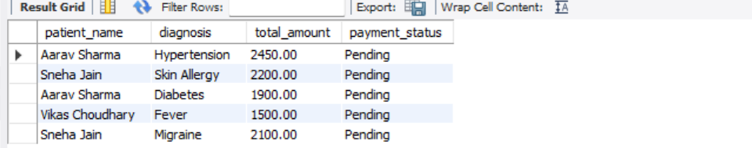

#B4--Q13. Find total billed amount by specialization, highest to lowest.
SELECT
d.specialization,
SUM(b.total_amount) AS total_revenue
FROM doctors d
INNER JOIN appointments a
ON d.doctor_id = a.doctor_id
INNER JOIN bills b
ON a.appointment_id = b.appointment_id
GROUP BY d.specialization
ORDER BY total_revenue DESC;
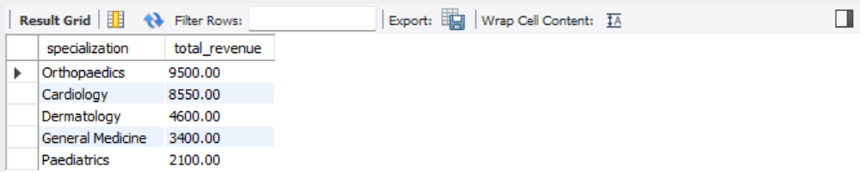

#Verify each tables:
SELECT * FROM patients;
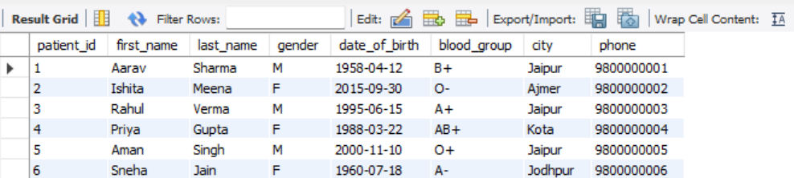
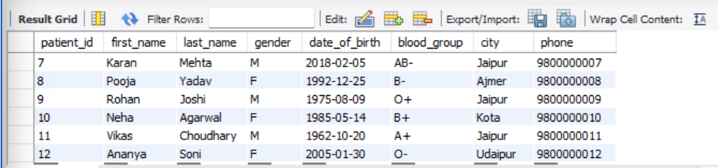

SELECT * FROM doctors;
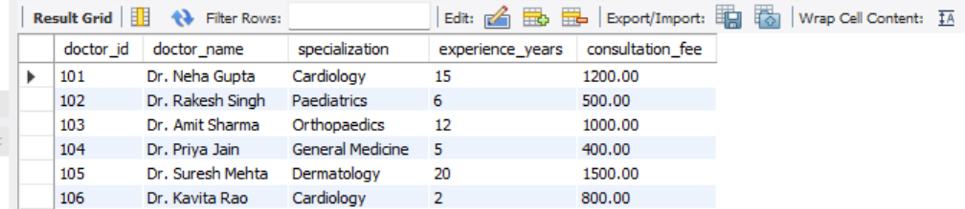

SELECT * FROM appointments;
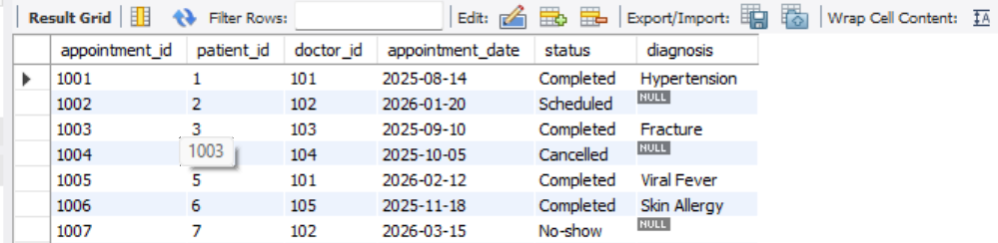
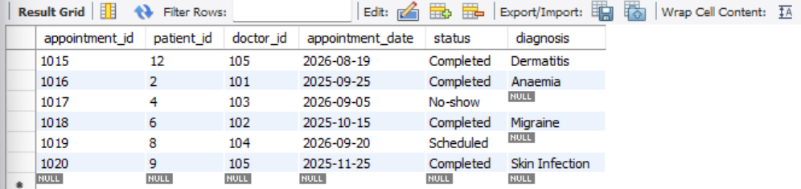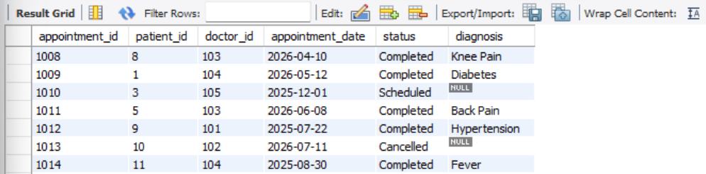

SELECT * FROM bills;
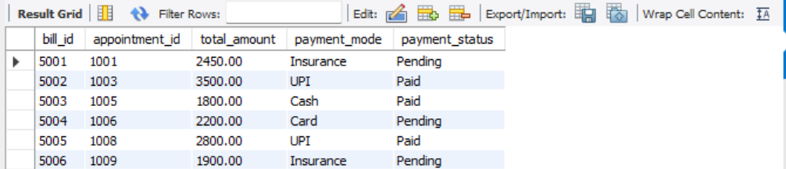
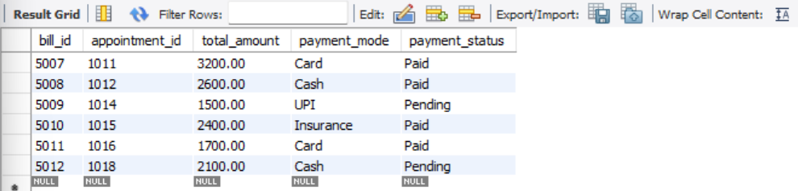

Part C:
SQL can help a hospital organise and analyse operational data in a consistent way. Patient records can be searched by city, blood group or other permitted fields, helping staff retrieve relevant information more quickly. Appointment queries can show daily workload, cancelled visits and no-shows, allowing the scheduling team to identify patterns and plan resources. Joining patient, doctor and appointment tables helps staff review visit history and understand which services are being used. Billing queries can identify pending payments and summarise billed amounts by medical specialization, supporting follow-up by the accounts team and financial reporting. Grouping and counting records can also help managers monitor service demand. In real hospital systems, access should be role-based, personal information should be protected, and reports should be checked for data quality before decisions are made.

